WEBSITE GO LIVE
  - Name Server Change

© PSXDigital
Prepared by: Amber Quirk
Email: amber@powersportsx.com | Phone: 727.505.5158

Contents
Nameservers Explained 4
What are nameservers? 4
What is propagation? 4
Why does propagation take so long? 4
How do I check? 5
Switching Nameservers 6
What do I change my nameservers to? 6
Instructions for Go Daddy 6
Instructions for Domain.com 7
Instructions for Bluehost.com 9
Instructions for Network Solutions 10

Nameservers Explained

What are nameservers?

Nameservers are part of DNS, which stands for “Domain Name System.” The DNS is a database that works like a phone book for computers: it converts a domain name, such as “www.example.com,” to a machine-readable IP address, such as “22.231.113.64.”

What is propagation?

The best way to think about website propagation is this: when you move, you generally fill out a forwarding address form with the post office. However, this transition isn’t immediate. It can take weeks for all your mail to find its way to your new home.
It’s a similar situation with your website. During website propagation – or your website “move” – your website’s “post office” (domain registrar) must tell the internet you’ve changed hosting (where your website lives).
While propagation occurs, you may see the following symptoms:
- The website is not resolving.
- The website is resolving to the previous version or host.
- The website works intermittently
  - The website works for some visitors in parts of the world, but not others.
  - The website works in certain browsers, but not others.
  - The website works on certain devices, but not others.
  - Etc...

Why does propagation take so long?
It takes time for the DNS to take effect across the internet. That’s a change that needs to take place on every DNS server in the world. Because each server has different caching rules in place, there’s not a standard for how long it may take each one to see the change.

How do I check?

Here is a way to keep track of the propagation on your site:
- Go to https://dnschecker.org/
- Under DNS CHECK type in the domain name (leave off any “www”)
- Click the blue “Search” button
- Look for the IP address 35.222.219.71
NOTE: To see just the United States servers, click the United States link first. This tool does not list all servers, this should just be used as a general ballpark to find out if propagation is almost complete.

Switching Nameservers

What do I change my nameservers to?

We use a DNS registrar called ENOM to Host your DNS. The nameservers will need to be switched to the below for your new site to begin propagation:
dns1.name-services.com
dns2.name-services.com
dns3.name-services.com
dns4.name-services.com
dns5.name-services.com

Instructions for Go Daddy

- Go to the DNS Management page.
- On the DNS Management page, under Nameservers, click Change.
- Under Choose your new nameserver type, select Custom.

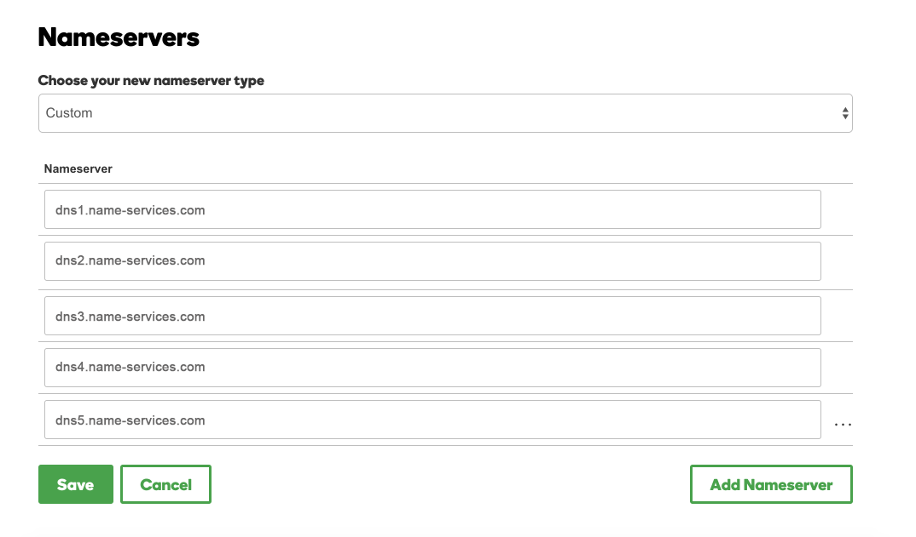

Instructions for Domain.com

- Select Manage on the domain you wish to access
- In Card view, click on the Manage button
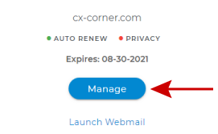
- In List view, click on the Gear icon
- Click on DNS & Nameservers in the left-hand menu.
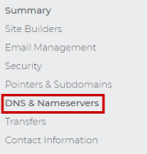
- Edit your Nameservers by clicking on Edit.
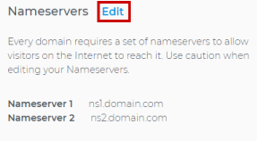
- Add a DNS Record by clicking the blue + button.
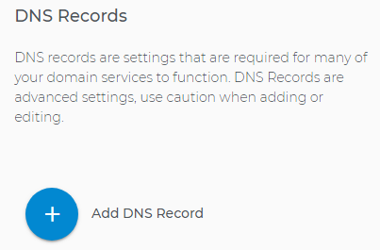

Instructions for Bluehost.com

- Login to your Bluehost Control Panel.
- Click the Domain link, at the top of the page.
- Choose your domain name from the list of domains.
- Then click the Name Servers tab.
- Select Use Custom Nameservers
- Enter in the new name servers.
- Click Save Nameserver Settings.

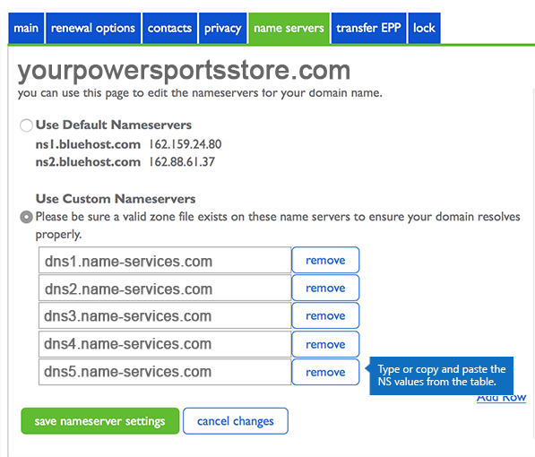

Instructions for Network Solutions

- Login to your Network Solutions Account.
- Under “My Domain Names”, choose “Edit DNS”

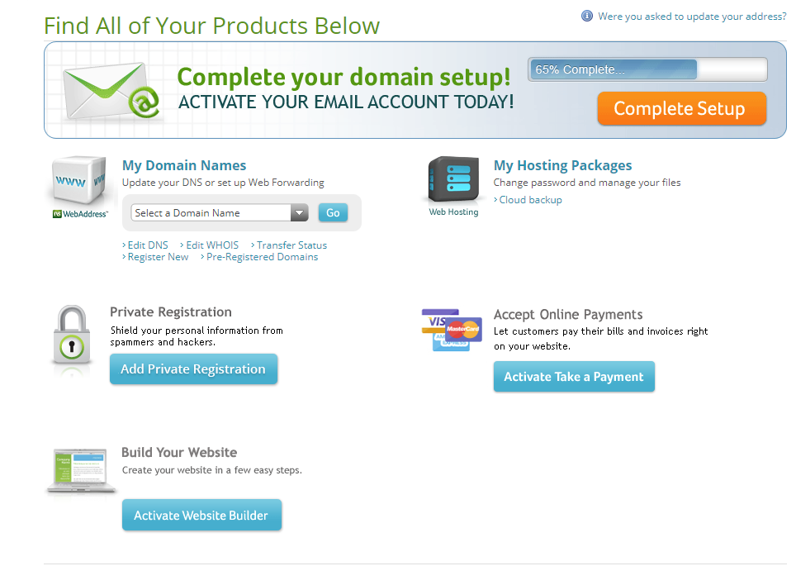

- Select any domain names that you will be changing the nameservers for and click “Edit DNS”

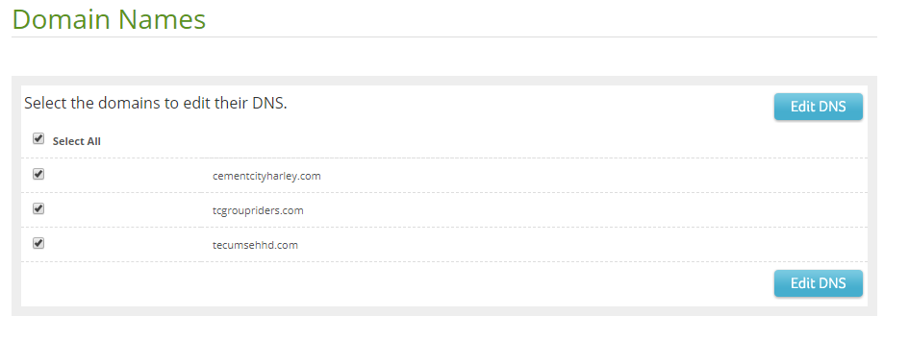

- Click the “Move DNS” button.

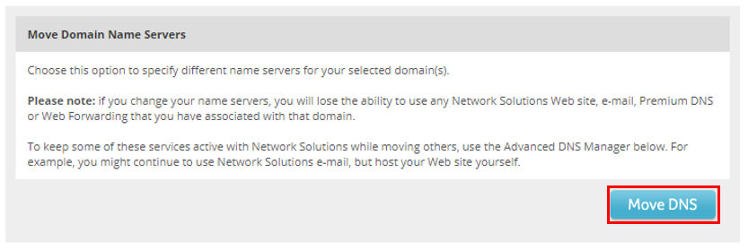

- Enter the new Nameservers
- Click “Move DNS”
